The Pottery Burn Studio Party Agreement
Reserved by: ________________________________________ for Date and Time: _____________________________

Phone: _____________________________________________ Number of Guests: ____________________________

Type of Event and Age Range (i.e. Birthday for 8 year olds) _____________________________________________________

Specific requests: _________________________________________________________________________________

ROOM FEE MUST BE PAID IN FULL AS A NON-REFUNDABLE FEE AT TIME OF BOOKING
1 | 2 | 3 | 4
Canvas  $10.99 per painter  8X10 pre-stenciled  Self-guided  - Ice cream cone  - Butterfly  - Panda  - Bird  (Canvas parties get access to our creation station & do not include a complimentary plate.  $40 Room Fee still applies) | Good Eats  $16 per painter  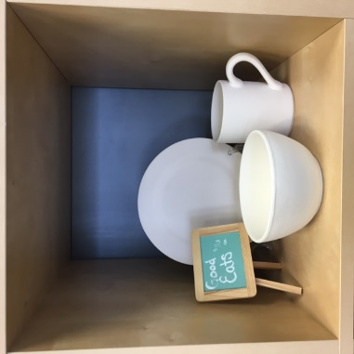 | Party Animals  $18 per painter  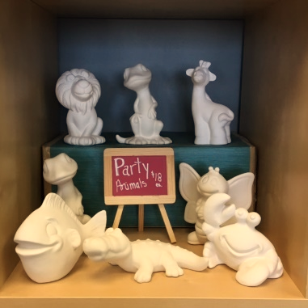 | Create Your Own  $15 minimum per painter  Choose from any bisque we offer & make your event unique!  Need a special order?  Give us a call to discuss.
Choose 1 package number & 1 package letter for a complete party
A | B | C | D
$30 Room Fee  2 Hour reservation  - 15 pre-determined paints  - Complimentary plate for guests to sign | $70 Room Fee  2 Hour reservation  - Full access to Paint Bar  - Complimentary plate for guests to sign | On-Site within 30 miles  $100 Travel charge  - 20 paints total  (15 pre-determined + 5 your choice)  - Basket of foam dotters, stamps, stencils & tape  - Complimentary plate for guests to sign  Pottery min. $300 | On-Site 30 to 60 miles away  $200 Travel charge  - 20 paints total  (15 pre-determined + 5 your choice)  - Basket of foam dotters, stamps, stencils & tape  - Complimentary plate for guests to sign  Pottery min. $300

Minimum of 6 painters required to reserve party room. Main studio can easily seat your smaller group, and we will still provide an enjoyable painting party. Party room seats up to 14 guests. Parties larger than that will need to make special arrangements

Room is reserved with 15 minutes allowed both before and after event for your set-up and take-down. You may bring in food, beverages or decorations. We ask that painting comes first as we don’t want any accidental damage to your masterpiece. We’ll handle normal cleaning of the room for our next guests. If more time is required, you may be asked to move into main room due to an incoming party.

Our staff is available to encourage your children, not to discipline them. A responsible adult should remain on-site at all times. Dangerous or destructive behavior will result in a shortened party.

Pottery Burn Studio parties larger than 14 guests will be priced on an individual basis by arrangement with owner.

Questions? Call Amanda Korhonen, Owner 715-718-8080 1207 Tower Ave Superior, WI 54880

thepotteryburnstudio@gmail.com www.thepotteryburnstudio.com

